In The Name of GOD
Role of MoS₂ and MoSe₂ thin films in performance of new generation CMTS solar cells made by pseudo co-evaporation method
Behnam Talebi, Mehrdad Moradi
Institute of Nanoscience and Nanotechnology, University of Kashan, Kashan, 8731753153, Iran
Abstract:
The structure of the absorber layer of the CMTS solar cell was made by a new quasi-evaporation method. The XRD and SEM analysis were used for crystallographic and topographic. Role of the intermediate layer which formed on the Mo/CMTS surface was investigated using SCAPS simulation. The results of XRD and SEM shown that the columnar and integrated growth. For the CMTS absorbent layer, the crystal structure of stannite, without additional peaks and with optimal intensity, indicates the achievement of pure growth and crystal structure with the desired crystal quality. Debye-Scherrer and Williamson-Hall calculations showed that the grain size and lattice strain were 60 nm and 0.8%, respectively. Parameters of fabricated layer were entered in the simulation section, and the role of MoS₂ and MoSe₂ interface layers in solar cell structure was investigated. In general, the n-type MoS₂ layer played a destructive role in cell performance. In comparison, the p-type MoS₂ and MoSe₂ layers improved the cell performance by improving the internal field. The best parameters (Voc: 0.75 eV, Jsc: 45.3 mA/cm², FF: 76.6%, and Eff: 26%) was obtained for the cell with MoSe₂ interlayer. Also, the optimal thickness for this layer was calculated in the range below 90 nm.

Introduction:
Recently, most of the research efforts and development in photovoltaic (PV) technology were directed toward improving their conversion efficiency, stability, and durability at a reduced production cost [1-3]. Chalcogenide materials have been considered promising materials for thin-film solar cells [4-5]. The CIGS and CdTe solar cells have developed as the most important chalcogenide semiconductors with a lab-scale power conversion efficiency exceeding 22.1% [6-10]. But the rare elemental constituents of In and Ga, and the toxicity of Cd have led to the limited deployment of these resources [11-14]. To date, the record photoelectric conversion efficiency of Cu₂ZnSn (S,Se)₄ thin film solar cells has been reported to be 12.6% [17-18]. However, the fabrication of pure kesterite phase CZTS is challenging due to the number of secondary and ternary phases observed in it [19-22]. The band grading is another issue-imposed challenge to progress the CZTS based thin film solar cells. There is also another key motivation in CZTSSe based solar cells, the electrostatic potential fluctuation of Cu–Zn antisite defects such as [Cu_{Zn}⁻ + Zn_{Cu}⁺] is suspected to be abundant, as they are next to each other in periodic table, which leads to severe potential fluctuations and tail states [23-26]. A severe tail states in CZTSSe is one of the dominant factors responsible for low open circuit voltage (Voc), which is the biggest challenge with current CZTSSe technology. Hence, replacement of Zn with other metals could provide a route to alter the defects and tail states in the absorber and to eventually improve the Voc [27-28]. On the other hand, the formation of n-type MoS₂ at the back contact is another limiting factor of better performance. MoS₂ thin film has been reported to exhibit both p and n-type conductivity. However, MoS₂ has a natural propensity to possess n-type semiconducting characteristics due to the presence native defects of S vacancies which acts as a deep donor [29-30]. Although, the conductivity of MoS₂ grown by sulfurization of Mo thin film has been conclusively determined as the n-type [31]. Numerical study, formation of n-MoS₂ is most likely to be responsible for the commonly observed high Rs and low fill factor [32]. Several attempts to inhibit or passivate this interfacial layer through an insertion of thin intermediate layer such as SnS, ZnO, TiN, Al₂O₃, or preferential heat treatment of Mo back contact have been stated. Since electronic band structure properties mainly electron affinity (χ) and band gap (Eg) of MoS₂ are profoundly dependent on the layer thickness [33]. One of the key research findings in the CIGS TFSCs is the ability of CIGS to make ohmic contact with the Mo back contact [34]. The formation of the p-type interfacial MoSe₂ film with thickness in the range of a few tens of nm is found to facilitate the development of ohmic contact, which is important to reduce series resistance. The similar beneficial aspects of MoSe₂ have been verified by numerical modeling of Mo back contact in Se-containing CZTSe devices [35].
There is an urgent need to find the alternatives for kesterite CZTS and an approach to substitute other elements for Cu or Zn [36]. Materials with structures, band gaps, and absorption coefficients analogous to those of CZTS, such as Cu2XSnS4 (X = Mn, Co, Fe) have been recently reported for photo voltage applications. The CMTS is counted as one of the most promising absorber materials in the thin-film solar cell segment because of its suitable p-type Cu₂MnSnS₄ (CMTS) [34]. Therefore, it has the potential to become another focus of the photo-electronic field because of their suitable band gap (1.20–1.50 eV) and optical absorption coefficients (> 10⁴ cm⁻¹) similar to the CZTS materials. In addition, the replacement of Zn by Mn in CZTS thin films decreases the optical band gap energy. Moreover, the most important thing is that the ionic radius of Mn (0.080 nm) is larger than that of Zn (0.074 nm), which can reduce the inherent anti-site defects and anti-site disorder [37-38]. So far, CMTS has mainly studied as a magnetic semiconductor in the form of single crystals or nanocrystals. Moreover, CMTS is composed of only earth-abundant, relatively non-toxic, and inexpensive elements. Actually, the abundance in the Earth’s crust of Mn is two orders of magnitude higher than that of Zn (1100 ppm vs 79 ppm) and the annual production of Mn (~1.6 ×107 tons) is higher than that of Zn (~1.2 × 107 tons) [39-40]. Therefore, since Mn is definitely cheaper than Zn, optimized CMTS could potentially provide a Wp cost definitely lower than CZTS, which is crucial for thin film PV applications [41]. Also, CMTS thin films are used as water-purification, catalysts for photocatalytic in Hydrogen Evolution Reaction (HER) [42], HTLs layer in Perovskite solar cells (PSCs) [43], and counter electrodes in dye-sensitized solar cells (DSSCs) [44]. Like CZTS solar cells, In the CMTS solar cells, a very thin MoS₂ layer may be grown on Mo back-contact material during the deposition of the very thin CMTS layer and MoS layer. In addition, the MoS₂ layer acts as a buffer between Mo and CMTS. Considering the dual nature of the MoS₂ layer, this layer is definitely very effective in the performance of CMTS solar cells. However, so far, the role of this layer has not been considered in any experimental or simulation work. Also, the MoSe₂ interfacial layer, which is studied in this paper, belongs to the group VI of the layered transition metal dichalcogenides family (TMDCs). These materials possess excellent physical and structural properties due to their significant 2D character. The material is composed of a Se-Mo-Se atomic layer where a strong in-plane covalent bonding exists, while weak Van der Waals forces bond the sheets together. Additionally, MoSe₂ compounds are characterized by the absence of dangling bonds, thermal stability, high hole mobility, and suitable bandgap values ranging from 1.0 eV up to 1.5 eV [45]. The electronic structure of the transition metal Mo in the MoSe2 is 4d²5s² and that of chalcogen Se is s²p⁴, i.e. both missing two electrons for a filled shell. They are semiconductors due to the weak p-d interactions. The electronic band structure both experimentally and in calculations of several families of TMDC materials was investigated comprehensively by many groups using different approaches and methods [46]. Crystals of such materials showed a good cleavage in the direction perpendicular to the layers (c-axis) [47].
In this work, we used a new approach to fabricate the CMTS solar cell. and after measuring its parameters, we investigated the role of the MoS₂ interlayer through simulation. Also, the role of MoSe₂ as a benign intermediate layer in the CMTS solar cell structure was investigated. The proposed results provide a valuable basis for designing high-performance CMTS-based solar cells.

Experimental:
Substrate preparation
To fabrication of the CMTS(S,Se) solar cell absorber thin layer, the SLG was used as substrate due to its wide application and favorable cost. In the substrate preparation stage, the slides were first cleaned from dust and grease with cleaning liquid. Then, for 10 minutes, it was placed in 0.02 M hydrochloric acid (HCl), deionized water, acetone (CO(CH₃)₂), deionized water, and ethanol in an ultrasonic bath. After finishing the washing process, the substrates were dried by pure nitrogen gas. All the preparation steps were done in a clean room environment without contamination.
Molybdenum coating
DC sputtering device was used for molybdenum coating. The target used for the sputtering process has a purity of 99.99%. Argon gas with a purity of 99.99% was used for ionization and plasma formation in the slow sputtering process. To achieve optimal adhesion and excellent conductivity of the layer, the sputtering process was performed at two different pressures. Primary pressure for better adhesion, in the range of 9×10⁻³ mbar, working voltage of 360 volts and 60% power, and secondary pressure for optimal conductivity and excellent crystal growth at a pressure of 2×10⁻³ mbar, working voltage of 380 volts and 65% power was done. The deposition rate was determined in the range of 8 angstroms/second and the final thickness of the layer was determined to be 800 nm. After finishing the layering process, the quality of the layers was analyzed to check the type of growth, adhesion, direction of crystal growth, and resistance measurement.
Growth of the CMTS absorbent layer
For fabrication of CMTS absorbent layer, a thermal evaporation device was used. The coating was done by pseudo-evaporation method. In this method, all four ingredients of the layer are placed in a set of layers and the materials are evaporated from different sources. The deposition process was done based on the diagram in Figure 1. The working pressure of the coating chamber was set in the range of 10⁻⁵ mbar. The temperature of the substrate maintained in the range of 90 °C. Then the samples were placed inside the steel crucible with a lid along with 0.5 g of selenium. The process of selenization and annealing was carried out in order to improve the crystalline properties, inside the furnace of the CVD device with the ability to manage temperature steps, at a pressure of 10⁻³ mbar and according to the temperature steps of diagram 2.
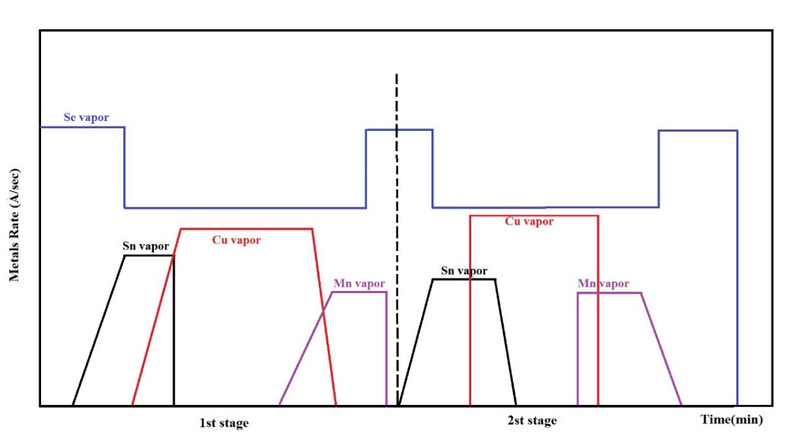
Fig. 1. Metal rate vs time profile of the two-stage semi co-evaporation process.
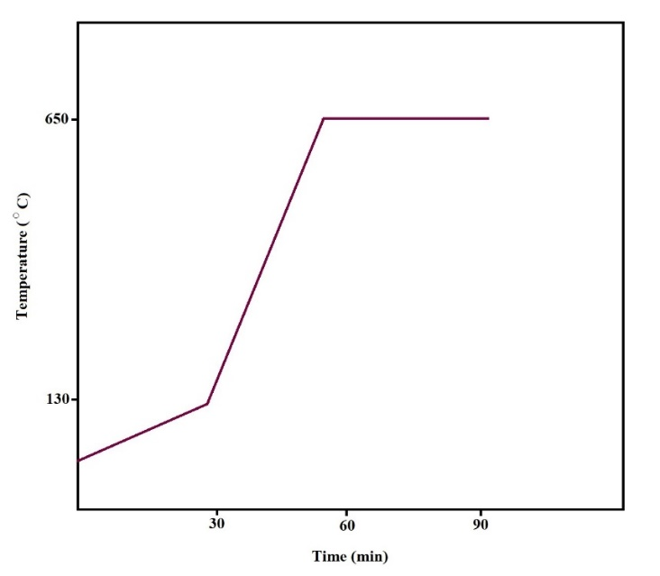
Fig. 2. Selenization and annealing condition for CMTS thin film product
Simulation section:
In this work, SCAPS-1D simulation software was used for modeling. Determine the pseudo-Fermi levels and the electrostatic potential e and h and in this way calculate other parameters such as carrier concentration, electric field and recombination level, etc. [48]. The simulation carried out under standard AM1.5 radiation and a temperature of 300 K. Figure 3 shows a schematic of the designed solar cell with the role of surface connections of each of the layers. The parameters which used for numerical analysis are listed in Table 1. According to the crystallography and XRD analysis results of Mo, the crystal growth direction is [110]. For the crystal growth of Mo, it can have different work functions of 4.36-4.95 eV. Therefore, according to the direction and type of Mo layer crystal growth, the Mo work function value was 4.95 eV in the simulation [49-50].
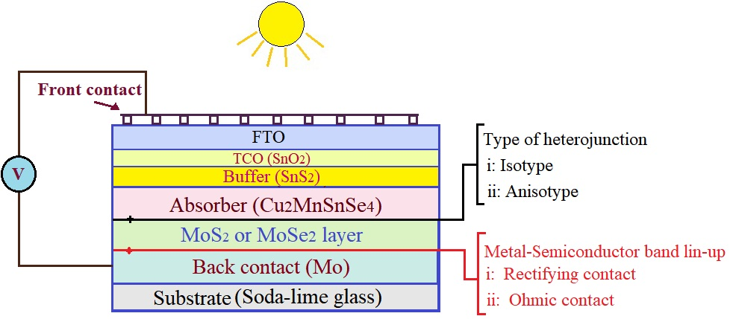
Fig. 3. Schematic of CMTS solar cell structure with Mo(S,Se)₂ layer interfaces attributes

Interface electronic properties such as back contact barrier height with respect to Ec (Φ_{Bn}), back contact barrier height with respect to Ev (Φ_{Bp}), equilibrium contact potential (qV_{o}), conduction band offset, CBO (ΔE_{c}), valence band offset, VBO (ΔE_{v}), and back diode built-in voltage (qV_{biback}) were calculated using the Eqs. (1)–(7). It is noteworthy that the CBO and VBO were calculated according to Anderson’s rule [51].

Փ_{Bn} = Փ_{Mo}–χ_{s} (1)
Փ_{BP}= Eg – Փ_{Bn} (2)
qV_{o} = Փ_{Mo} – Փ_{s}; for n type semiconductor/metal junction (3)
qV_{o}= Փ_{s} – Փ_{Mo}; for p type semiconductor/metal junction (4)
∆E_{c} = χ_{CMTS} – χ _{Mo(S,Se)2} ; for Mo(S,Se)₂ /CMTS heterojunction (5)
∆E_{V}= (χ_{Mo(S,Se)2}+Eg_{Mo(S,Se)2}) – (χ_{CMTS}+ Eg_{CMTS} ); for Mo(S,Se)₂/CMTS heterojunction (6)
qV_{biback} =Փ _{Mo(S,Se)2} – Փ _{CMTS} ; for Mo(S,Se)₂ /CMTS heterojunction (7)
Whereby, the Փ_{Mo} is the Mo metal work function while Փ_{s} is the work function of the semiconductor. The Փ_{S} of n and p-type semiconductors was calculated according to Eqs. (8) and (9), respectively.
Փ_{S}=χ_{S} +( kTln$\frac{N_{C}}{N_{D}}$); for n type semiconductor (8)
Փ_{S}=χ_{S} +Eg– ( kTln$\frac{N_{V}}{N_{A}}$); for P type semiconductor (9)
whereby, q, k, T, N_{D}, N_{A}, N_{C}, and N_{V} are electron charge, Boltzmann constant, temperature, donor concentration, acceptor concentration, effective density of states in the conduction band and effective density of states in the valence band, respectively. The metal-semiconductor junction can either be ohmic or rectifying depending on the relative magnitude of work function (Φ) of metal and semiconductor [52]. For a Schottky Mo/p-type semiconductor structure, qV_{o} is the potential barrier retarding hole transport from the semiconductor valence band to metal, meanwhile for a Schottky Mo/n-type semiconductor structure, qV_{o} is the potential barrier retarding electron transport from the semiconductor conduction band to metal. Values for qV_{o} are always positive for Schottky type contact and negative for ohmic type contact. The inclusion of MoS₂ layer in between Mo and CMTS is expected to alter the charge carrier transport dynamics in the back contact region of CMTS TFSC [53]. Energy band diagrams of Mo, MoS₂, MoSe₂ and CMTS in isolation are shown in Figure 4.
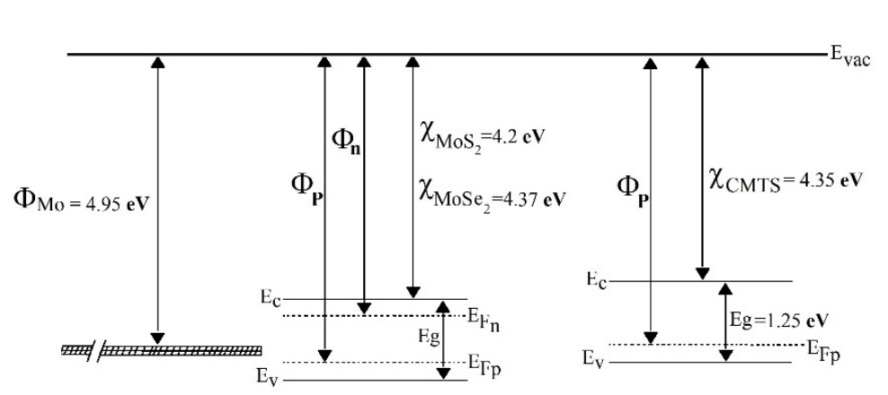
Fig. 4. Energy band diagrams of Mo, MoS₂, MoSe₂ and CMTS in isolation

Table 1. The optoelectronic parameters used for this numerical simulation study and investigation [23, 45, 54-62]
Parameters | n-MoS₂ | p-MoS₂ | MoSe₂ | CMTS | SnS₂ | SnO₂ | FTO
Thickness (nm) | 5-150 | 5-150 | 5-150 | 1000 | 50 | 100 | 200
Bandgap, E_{g} (eV) | 1.45 | 1.4 | 1.2 | 1.2 | 1.85 | 3.6 | 3.5
Electron affinity, χ (eV) | 4.2 | 4.2 | 4.12 | 4.35 | 4.26 | 4.5 | 4.3
Dielectric permittivity, Ɛ_{r} | 13.6 | 13.6 | 13.6 | 9 | 17.7 | 9 | 10
CB effective density of states, N_{c} (cm⁻ ³) | 7.5$×$10¹⁷ | 2.2$×$ 10¹⁸ | 2.2$×$ 10¹⁸ | 2.2$×$ 10¹⁸ | 7.3$×$ 10¹⁸ | 2.2$×$ 10¹⁸ | 1.8$×$ 10¹⁹
VB effective density of states, N_{v} (cm⁻ ³) | 1.8$×$10¹⁸ | 1.8$×$ 10¹⁹ | 1.8$×$ 10¹⁹ | 1.8$×$ 10¹⁹ | 1.8$×$ 10¹⁹ | 1.8$×$ 10¹⁹ | 1.8$×$ 10¹⁸
Electron thermal velocity V_{th}, e (cm/s) | 1$×$ 10⁷ | 1$×$ 10⁷ | 1$×$ 10⁷ | 1$×$ 10⁷ | 1$×$ 10⁷ | 1$×$ 10⁷ | 1$×$ 10⁷
Hole thermal velocity V_{th}, h (cm/s) | 1$×$10⁷ | 1$×$ 10⁷ | 1$×$ 10⁷ | 1$×$ 10⁷ | 1$×$ 10⁷ | 1$×$ 10⁷ | 1$×$ 10⁷
Electron mobilities, μ_{e} (cm²/Vs) | 100 | 100 | 100 | 16 | 50 | 100 | 20
Hole mobilities, μ_{h} (cm²/Vs) | 25 | 25 | 25 | 16 | 25 | 25 | 10
Shallow uniform donor density N_{D} (cm⁻ ³) | 1$×$10¹⁵ | 0 | 0 | 0 | 9.5$×$ 10¹⁸ | 1$×$ 10²⁰ | 1$×$ 10¹⁸
Shallow uniform acceptor density N_{A} (cm⁻ ³) | 0 | 1$×$ 10¹⁵ | 1$×$ 10¹⁶ | 1$×$ 10¹⁶ | 0 | 0 | 0
Total defect density, N_{t} (1/cm³) | 1.2$×$10¹² | 1.2$×$10¹² | 1.2$×$10¹² | 1.2$×$ 10¹¹ | 1 $×$ 10¹⁵ | 1$×$ 10¹⁶ | 1$×$ 10¹⁸

The Mo layer showed excellent adhesion in the stress and solution tests. Crystallographic investigation was carried out by XRD. The diffraction spectrum diagram of the Mo layer was shown in Figure 5. The results indicates the cubic structure with the card number 00-042-1120 and the growth of the single crystal layer in the preferential direction [110] with the desired intensity. Measurements of sheet resistance analysis were done by four-points probe. The obtained results indicate a resistance in the range of 0.2 Ω/□, which is perfect for the back connection of the solar cell. The cross SEM is presented in Figure 6 which show a single piece and columnar growth.
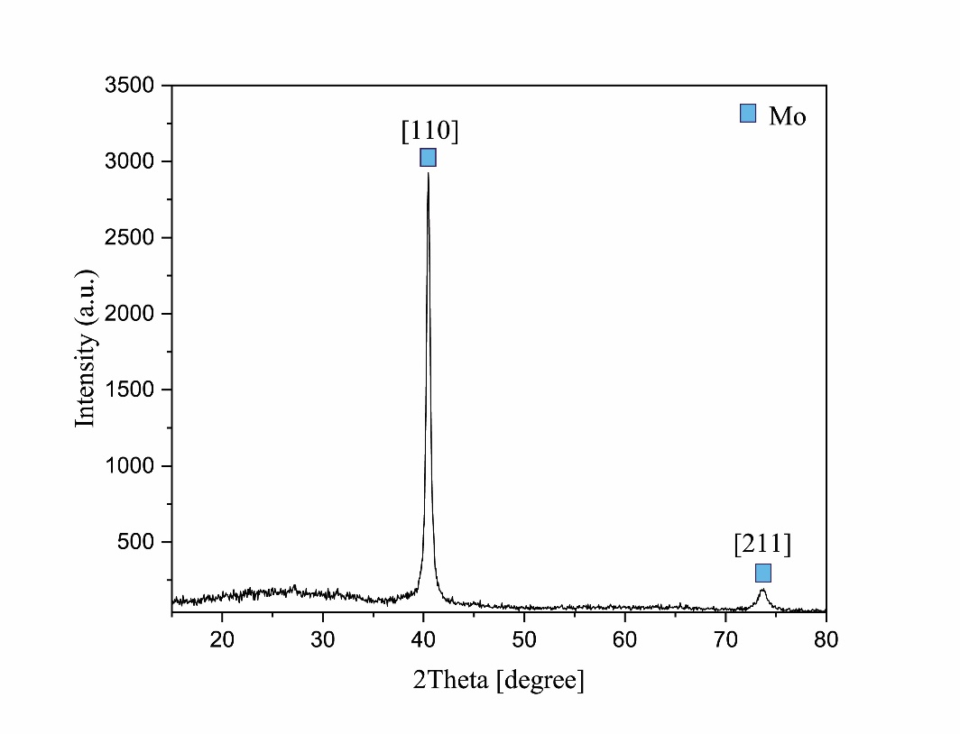
Fig. 5. X-ray diffraction pattern of Mo thin film
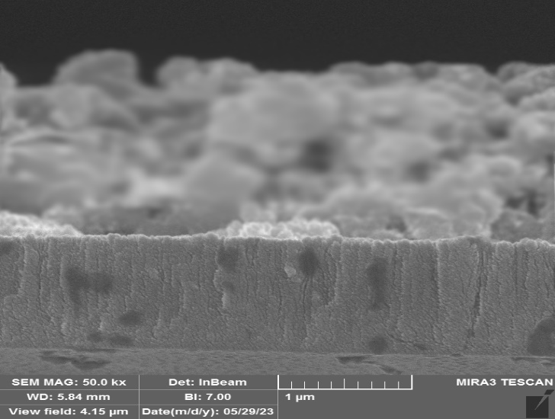
Fig. 6. SEM image of Mo layer on soda lime glass
The CMTS semiconductor absorber layer was made by physical quasi-evaporation method. Based on the analyzing the XRD results (in figure 7), there are two crystal structures related to CMTS and MoSe₂ in the structure, which is the dominant peak related to the CMTS structure. The location of the peaks for the CMTS structure with card number 00-026-0542 and for the MoSe₂ structure with card number 00-020-0757 of the software for analyzing the results of this analysis (Xpert high score) are completely consistent and indicate the tetragonal crystal structure with the name Stanit is exclusive to CMTS. The absence of additional peaks and the optimal intensity of the peaks indicate the achievement of a crystal structure with optimal crystal quality.
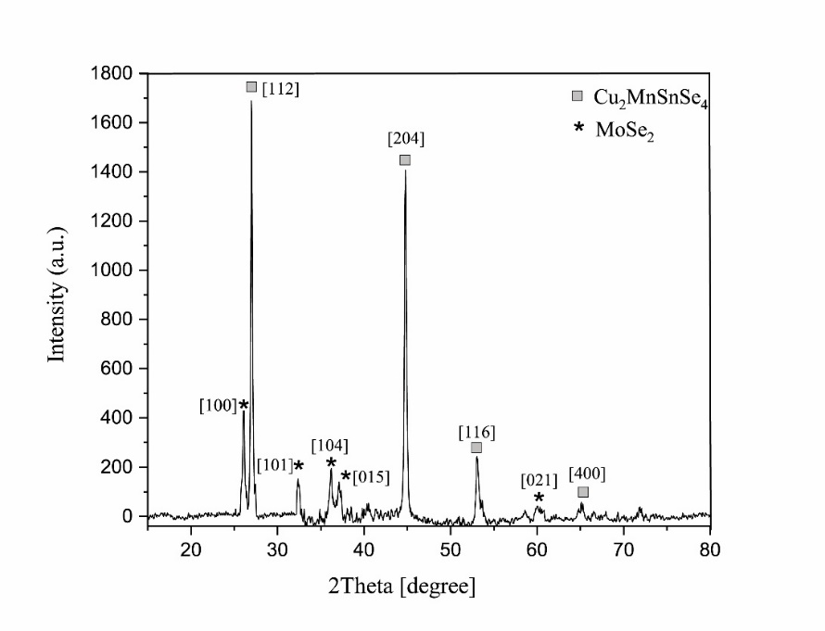
Fig. 7. X-ray diffraction pattern of CMTS thin film
The Williamson-Hall method was used to measure the lattice strain of fabricated structure, and Debye-Scherr relationship on the peaks of the XRD diagram was used to calculate the grain size. According to the Williamson-Hall relationship, XRD peak broadening is caused by two parameters: crystallite size and lattice strain. The following relationship is used for Williamson-Hall calculations:
$$B_{X}Cosθ=4 ε Sinθ+\frac{Kλ}{D}$$
Here, B_{t} is the amount of total broadening in half peaks, ε is the amount of lattice strain, λ is the wavelength, D is the crystallite size and θ is the diffraction angle. By entering the parameters, the diagram of Figure 8 is obtained. The line slope in the diagram shows the amount of lattice strain and the Y-intercept, which results in the crystallite size range. By performing calculations, the amount of network strain was very low and in the range of 0.8%. According to the Debye-Scherr relation, the size of the crystallites was calculated in the range of 40-50 nm.
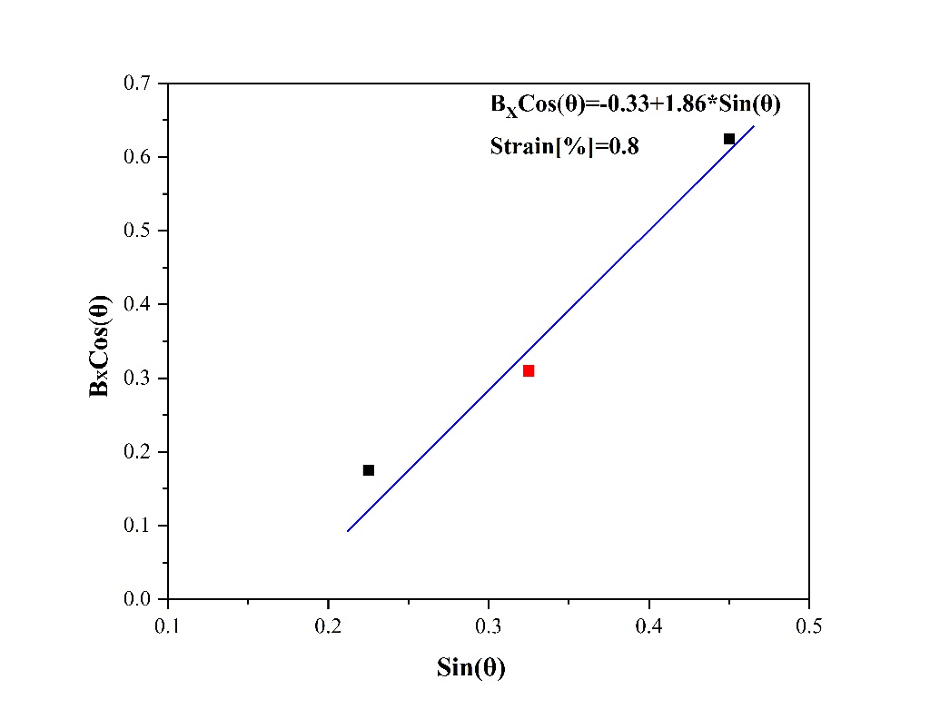
Fig. 8. Williamson-Hall diagram for lattice strain calculations

SEM & EDS results
The morphology and chemical composition of the CMTS thin film were investigated by a MIRA3 Tescan Field Emission Scanning Electron Microscope (FESEM) equipped with Energy-Dispersive Spectroscopy (EDS). The operating voltage used for all the SEM images was 20 kV, while EDS analyses were performed by a Quantax system (Bruker) under the following conditions: operating voltage 20 kV, probe current 150 pA, probe size 5 nm, working distance 15 mm, with inner calibration on pure metals. Table 2 shows the percentage of elements in the structure of CMTS thin film. According to reports and formula the percentage of optimal elements for CMTS structure should be close to 25, 12.5, 12.5 and 50 percent for Cu, Mn, Sn and Se elements, respectively.
The results of EDS indicate the achievement of ideal elemental percentages in the structure are in agreement with theoretical and experimental theories. Figure 9 shows the cross-section SEM image of the CMTS thin film from the area along with the elemental distribution diagram (EDS) of the structure. The images obtained from the SEM show the existence of a one-piece structure with columnar growth and the least amount of holes, with a large grain size, which is ideal for an absorbent layer.

Table 2. Percentage of elements in the structure of CMTS thin film
Composition ratio |  |  | Chemical composition  Atomic percent (%)
Se/Metal | Mn/Sn | Cu/(Mn + Sn) | Se | Sn | Mn | Cu
1.12 | 1.09 | 1.04 | 53 | 11 | 12 | 24

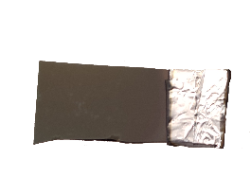
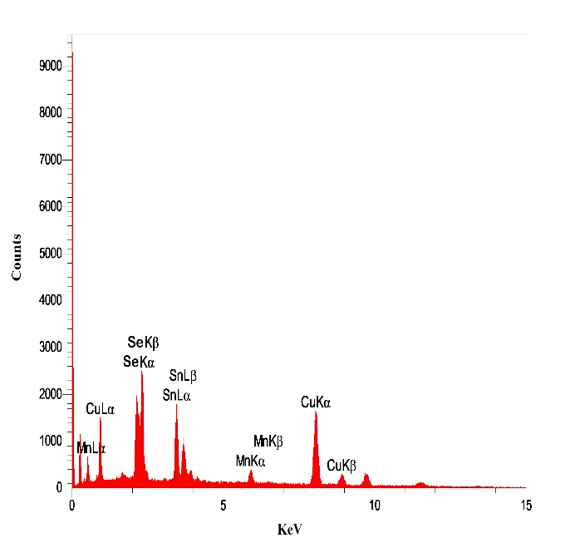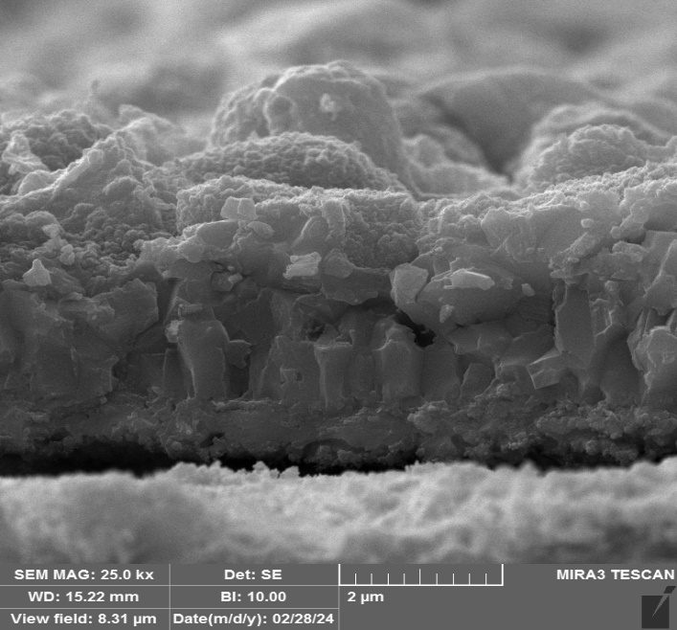
Fig. 9. SEM image and EDS analysis result for CMTS thin film
High absorption rate and band gap in the maximum range of solar radiation are important for the materials used as solar cell absorbers. The UV-Vis-NIR absorption spectrum of the CMTS absorber layer showed a broad absorption in this structure.
The direct optical band gap energy of CMTS compound was calculated using Tauc’s formula and by extrapolating the linear region of the spectra: (αhυ)² = A(hυ - E_{g})^{n} ($α=\frac{1}{t} ln⁡(\frac{I_{0}}{I})$).
The band gap of CMTS layer can be estimated from (αhυ)² versus hυ plots (α = absorption, Planck's constant = h and υ = frequency) derived from the corresponding UV-vis-NIR absorption spectra. Figure 10 shows the graphs related to this absorption spectrum and the band gap of the CMTS thin film. The band gap is approximately 1.25eV. This value is in acceptable agreement with the reported values in addition to the optimal range of absorption
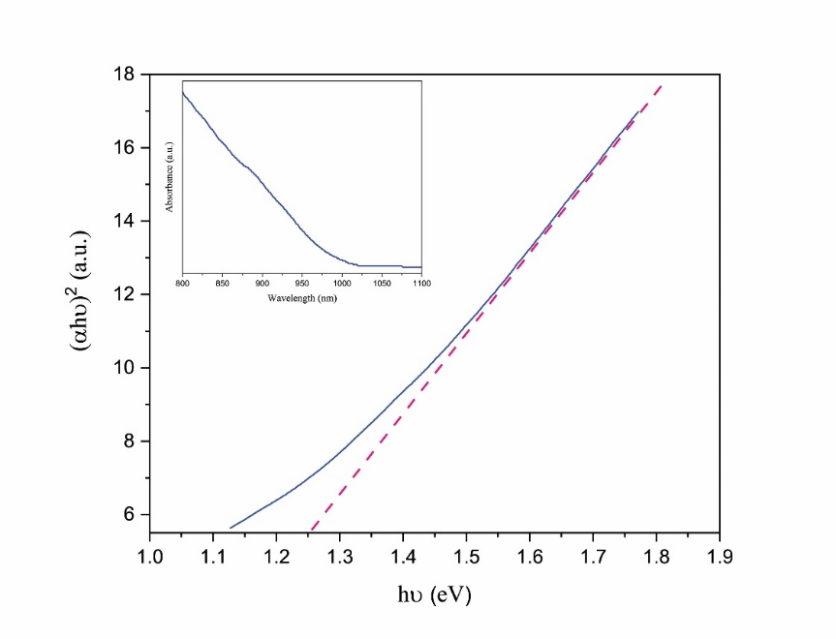
Fig. 10. UV-Vis-NIR absorption spectrum plot and energy band gap calculation for CMTS semiconductor structure using extrapolation.

Simulation results
The simulation of the modern CMTS solar cell structure was done by the SCAPS solar cell simulation software. The results of the I-V analysis of the fabricated solar cell are presented in Figure 11. In order to analyze the results and investigate the role of key parameters in the connection points of the Mo/Mo(S, Se)₂ and Mo (S, Se)₂/CMTS levels, specialized calculations were performed through relations 1 to 8 of the simulation method. The results of these calculations for the manufactured solar cell are presented in Table 3.
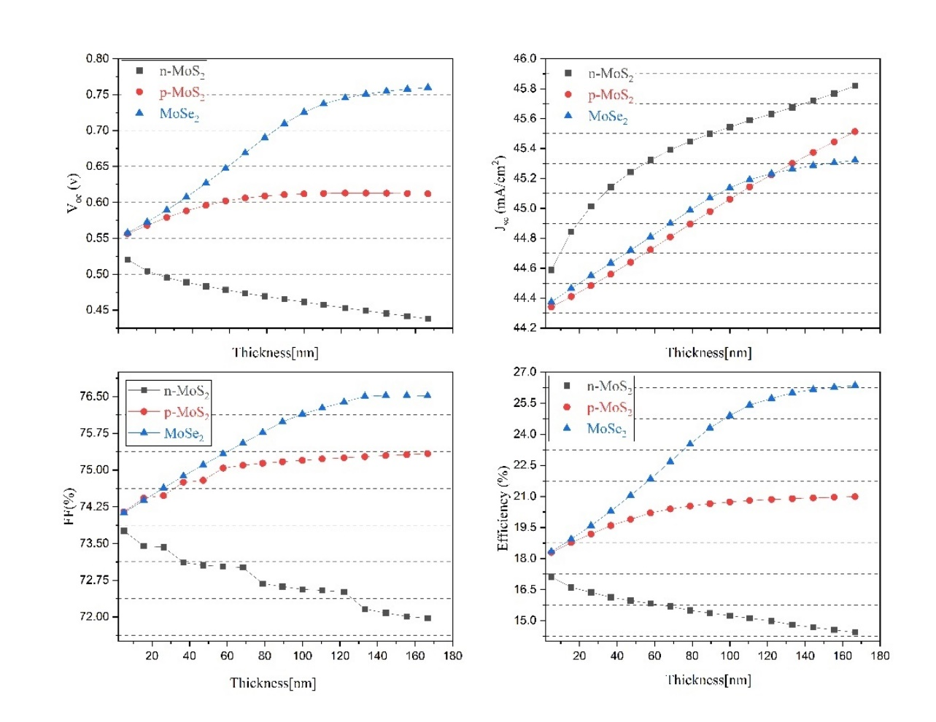
Fig. 11. The role of thicknesses of different interface layers between Mo/CMTS in the basic PV parameters

Table 3. Calculated interface electronic parameters of Mo/MoS₂-MoSe₂/CMTS
Interface M-S | Φ_{Bn} | Φ_{Bp} | qv_{o} | Φ_{s} | Heterojunction | ∆E_{c} | ∆E_{v} | qV_{biback}
Mo/n-MoS₂ | 0.75 | 0.7 | 0.58 | 4.37 | n-MoS₂/CMTS | 0.15 | 0.1 | -1
Mo/p-MoS₂ | 0.75 | 0.65 | 0.43 | 5.38 | p-MoS₂/CMTS | 0.15 | 0.05 | 0.1
Mo/ MoSe₂ | 0.83 | 0.37 | 0.23 | 5.18 | MoSe₂/CMTS | 0.23 | -0.23 | -0.19

The band alignment at the interface of Mo(S,Se)₂/absorber highly affects the V_{OC}. The conduction band offset (CBO) determines whether the band bending at the interface is spike, flat or cliff. A spike at the interface, inhibits recombination at the interface, while a cliff type band bending results in higher interface recombination and lower V_{OC} [63]. The conduction band offset (CBO) between the Mo(S,Se)₂ and absorber layers is important in the formation of a contact interface. Variation in χ shifts the whole band structure of a material upward or downward. This in turn has an effect on ΔE_{c} and ΔE_{v} of the Mo(S,Se)₂/CMTS heterojunction and Φ_{Bp}, Φ_{Bn} and qV_{o} of the Mo/ Mo(S,Se)₂ metal-semiconductor junction [52]. For example, MoS₂ with χ 4.2 eV has ΔEc and ΔEv of 0.15 eV and 0.05-0.1 eV, while MoSe2 χ 4.12 eV has a 0.8 eV increase in ΔEc relative to MoS₂ and a decrease in ΔEv. The value of 0.2 eV spike in the conduction band is ideal to prevent electron emission in the back connection. The transition of ΔEv value from positive to negative suggests the ease of hole flow from CMTS to back contact through MoS₂. The positive ΔE_{v}, which corresponds to an energy barrier for the lower energy holes of CMTS towards the Mo(S,Se)₂. This inhibition of hole flow towards back contact is undesired and detrimental for effective carrier collection [31]. On the other hand, for the MoSe₂, lower χ yields negative ΔE_{v} indicating ease of hole flow from the higher energy valence band of CMTS to the lower energy valence band of MoSe₂. This supports the results obtained from simulations as observed in Fig.9. The low height ΔE_{v} helps to easy hole transfer. So, MoSe₂ has a more benefit for V_{oc} and efficiency which is in complete agreement with the results obtained.
Generally, for Mo/p-Mo(S,Se)₂/CMTS band alignment, lower negative qV_{biback} or higher positive qV_{biback} and lower qV_{o} are desirable for hole transport across the valence band of CMTS to valence band of p-MoS2 and from valence band of p-MoS₂ to Mo metal. The intended direction of hole flow during charge carrier separation is toward the back contact. The n-MoS₂ generally forms a back diode with higher negative qV_{biback} compared to p-MoS₂ and MoSe₂, which in turn, inhibits the hole transport from the CMTS layer to the MoS₂ layer. Although positive qV_{biback} has been observed for p-MoS₂ which is supposedly to act as a beneficial back surface field, degradation PCE is still observed due to the positive ΔE_{v} and high Φ_{Bp} and qV_{o} value. High Φ_{Bp} and qV_{o} are responsible for the inhibition of hole transport from the p-MoS₂ to the Mo back contact. According to the obtained results, the values of Φ_{Bp} and qV_{o} in the MoSe₂ layer show the optimality of this layer for the CMTS structure. For an n-MoS₂/Mo junction, Φ_{m} > Φn results in rectifying contact. Given a Φ_{m} of 4.95 eV, any Φ_{n} < 4.2 eV yields a rectifying contact. As a result, the increase in current with the increase in the thickness of the n- MoS₂ layer is due to the ohmic connection of this layer with Mo. For a p-MoS₂/Mo junction, Φ_{m} < Φ_{p} yields a rectifying contact that is undesired in case of hole flow. As seen, n-MoS₂ is already detrimental as it forms a back diode with p-CMTS which opposes the working built-in potential of p-CMTS/n-SnS₂ primary diode (n-p-n). These too correlate with results from Fig. 9 and existing literature [64]. The p-MoS₂ and MoSe₂ thin films have the added advantage of having the back diode condition lesser negative values, resulting in better performance (p-p-n). We numerically showed that the n-type MoS2 interfacial layer with Low thickness acts as a considerably benign component, whereas, the p-type MoS2 MoSe2 interfacial layer generally induces beneficial back contact carrier transport characteristics and subsequently improves the CMTS TFSCs performance. The optimal thickness for this layer was calculated in the range below 90 nm. The obtained solutions and results help researchers in this field a lot in achieving the optimal efficiency of CMTS thin film solar cells.

Conclusions:
The CMTS solar cell absorber layer was fabricated through a new quasi-evaporation method. The investigation of the analyses indicated a unified structure with the direction of crystal growth and favorable topography along with ideal absorption and band gap in the range of 1.25 eV. The data obtained from the analyses were used in the simulation process. Due to the variation in the semiconductor model of this layer, the effective parameters at the connection points of this layer with Mo and CMTS were investigated. The presence of an n-type MoS₂ layer in low thicknesses is desirable due to the creation of an ohmic connection at the Mo junction. However, due to the difference in the internal field of the cell due to the creation of the opposite diode behind the cell (n-p-n) and the formation of recombination points, increasing the thickness of this layer should be avoided. Regarding the p-type MoS₂ layer, the existence of the diode aligned with the CMTS helps to increase the amount of internal field and creates a small obstacle for the movement and exit of the hole from the Mo back electrode. MoS₂ thin film with a thickness of 60 nm creates a 21% efficiency for the solar cell. The existence of the MoSe₂ thin film in the junction between Mo and CMTS layers greatly improved the cell performance. The existence of a suitable band gap, optimal parameters at the Mo and CMTS connection points, and the contribution to the internal field due to the alignment are important factors for the optimality of the MoSe₂ layer in these solar cells. The highest efficiency and the best performance among the investigated layers were assigned to the MoSe₂ layer with an efficiency of 26%.
Acknowledgment:
The authors thank Dr. Marc Borgelman and her research team at Ghent University, Belgium for producing and developing the SCAPS simulation program and making it freely available to the public.

Authors' contributions: B. T. carried out the experiments and wrote the manuscript’s draft. M. M. supervised the research, wrote the manuscript’s draft, and reviewed.
Statements and declarations
Funding: Not applicable.
Conflicts of interest/Competing interests: The authors declare that they have no conflict of interest.
Availability of data and material: The data will be available upon reasonable request.
Consent for publication: By submitting the manuscript, the authors understand that the material presented in this manuscript has not been published before, nor has it been submitted for publication to another journal. The corresponding author attests that this study has been approved by all the co-authors concerned.
Ethical Approval statement: Not applicable.

References
[1] J. Yu et al., "The role of tuning Se/(S+ Se) ratio in the improvement of Cu2MnSn (S, Se) 4 thin films properties and photovoltaic device performance," Solar Energy, vol. 179, pp. 279-285, 2019.

[2] B. Talebi, M. Moradi,"Solvothermal synthesis of CMTS quaternary semiconductor nanoparticles with a symmetric kesterite structure: The role of the autoclave filling factor, " Nano-Structures & Nano-Objects, vol. 35, pp. 101008, 2023.
[3] M. Zahedifar, E. Ghanbari, M. Moradi, and M. Saadat, "Optimized annealing regime of CuGaSe2 nanoparticles prepared by solvothermal method," physica status solidi (a), vol. 212, no. 3, pp. 657-661, 2015.

[4] M. Moradi, M. Zahedifar, T. Ghorbani, M. Saadat, and K. Rostami, "OPTIMAL CONDITIONS FOR PREPARING CIGS THIN FILM THROUGH TWO-STEPPROCESS OF SPUTTERING FOLLOWED BY SELENIZATION," Studia Universitatis Babes-Bolyai, Chemia, vol. 61, no. 1, 2016
[5] M. Saadat, O. Amiri, and P. Mahmood, "Analysis and performance assessment of CuSbS2-based thin-film solar cells with different buffer layers," The European Physical Journal Plus, vol. 137, no. 5, pp. 1-12, 2022.
[6] N. Beyrami, M. Saadat, and Z. Sohbatzadeh, "A modeling study on utilizing In2S3 as a buffer layer in CIGS-based solar cells," Journal of Computational Electronics, vol. 21, no. 6, pp. 1329-1337, 2022.
[7] M. Moradi, R. Teimouri, M. Saadat, and M. Zahedifar, "Buffer layer replacement: a method for increasing the conversion efficiency of CIGS thin film solar cells," Optik, vol. 136, pp. 222-227, 2017.

[8] Z. Rajabi, M. Moradi, and M. Zahedifar, "Back contact selenization and absorber layer etching for improvement in Schottky diode behavior of [Mo/CIGS/Al] structure," Materials Research Express, vol. 6, no. 6, p. 065501, 2019.

[9] M. Saadat and O. Amiri, "Fine adjusting of charge carriers transport in absorber/HTL interface in Sb2 (S, Se) 3 solar cells," Solar Energy, vol. 243, pp. 163-173, 2022.

[10] M. Saadat, M. Moradi, and M. Zahedifar, "Optimization of Zn (O, S)/(Zn, Mg) O buffer layer in Cu (In, Ga) Se2 based photovoltaic cells," Journal of Materials Science: Materials in Electronics, vol. 27, no. 2, pp. 1130-1133, 2016.

[11] M. Moradi, R. Teimouri, M. Zahedifar, and M. Saadat, "Optimization of Cd1− yZnyS buffer layer in Cu (In, Ga) Se2 based thin film solar cells," Optik, vol. 127, no. 8, pp. 4072-4075, 2016.

[12] M. Saadat, O. Amiri, and P. H. Mahmood, "Potential efficiency improvement of CuSb (S1-x, Sex) 2 thin film solar cells by the Zn (O, S) buffer layer optimization," Solar Energy, vol. 225, pp. 875-881, 2021.
[13] M. Saadat, O. Amiri, and A. Rahdar, "Optimization of (Zn, Sn) O buffer layer in Cu (In, Ga) Se2 based solar cells," Solar Energy, vol. 189, pp. 464-470, 2019.
[14] M. Saadat, M. Moradi, and M. Zahedifar, "CIGS absorber layer with double grading Ga profile for highly efficient solar cells," Superlattices and Microstructures, vol. 92, pp. 303-307, 2016.
[15] W. Wang et al., "A general oxide-based preparation strategy for Cu2MSnS4 (M: Zn, Mn, Cd) thin films and relevant solar cells," Materials Letters, vol. 214, pp. 170-173, 2018.
[16] X. Wang, X. Gu, H. Guan, and F. Yu, "Flower-like Cu2MnSnS4 particles synthesized via microwave irradiation method," Chalcogenide Lett, vol. 12, pp. 99-103, 2015.
[17] T. Raadik, M. Grossberg, J. Raudoja, R. Traksmaa, and J. Krustok, "Temperature-dependent photoreflectance of SnS crystals," Journal of Physics and Chemistry of solids, vol. 74, no. 12, pp. 1683-1685, 2013.

[18] G. Cui, Y. Yang, R. Chen, and C. Zhu, "Influence of extra trace Mn-doping on the properties of Cu2ZnSn (S, Se) 4 absorber layer," Optical Materials, vol. 111, p. 110707, 2021.
[19] T. Gershon et al., "Unconventional kesterites: The quest to reduce band tailing in CZTSSe," Current Opinion in Green and Sustainable Chemistry, vol. 4, pp. 29-36, 2017.
[20] L. Guo et al., "Electrodeposited Cu2ZnSnSe4 thin film solar cell with 7% power conversion efficiency," Progress in Photovoltaics: Research and Applications, vol. 22, no. 1, pp. 58-68, 2014.
[21] J. Li et al., "Tailoring the defects and carrier density for beyond 10% efficient CZTSe thin film solar cells," Solar Energy Materials and Solar Cells, vol. 159, pp. 447-455, 2017.
[22] G. Gurieva, S. Niedenzu, N. Siminel, A. Franz, and S. Schor, "The kesterite–stannite structural transition as a way to avoid Cu/Zn disorder in kesterites: the exemplary case of the Cu2 (Zn, Mn) SnSe4," Faraday Discussions, vol. 239, no. 51, pp. 51-69, 2022.
[23] M. Haghighi, M. Minbashi, N. Taghavinia, D.-H. Kim, S. M. Mahdavi, and A. A. Kordbacheh, "A modeling study on utilizing SnS2 as the buffer layer of CZT (S, Se) solar cells," Solar Energy, vol. 167, pp. 165-171, 2018.
[24] A. Polizzotti, I. L. Repins, R. Noufi, S.-H. Wei, and D. B. Mitzi, "The state and future prospects of kesterite photovoltaics," Energy & Environmental Science, vol. 6, no. 11, pp. 3171-3182, 2013.
[25] Y. Cui, R. Deng, G. Wang, and D. Pan, "A general strategy for synthesis of quaternary semiconductor Cu 2 MSnS 4 (M= Co 2+, Fe 2+, Ni 2+, Mn 2+) nanocrystals," Journal of Materials Chemistry, vol. 22, no. 43, pp. 23136-23140, 2012.
[26] J. Li, Y. Wang, G. Jiang, W. Liu, and C. Zhu, "Cu2MSnS4 (M: Zn, Cd, Mn) thin films fabricated with stacked layers by CBD-annealing route," Materials Letters, vol. 157, pp. 27-29, 2015.
[27] Y. Sun et al., "A promising photovoltaic material Cu2MnSn (S, Se) 4: Film growth and its application in solar cell," Solar Energy Materials and Solar Cells, vol. 219, p. 110788, 2021.

[28] R. R. Prabhakar et al., "Photovoltaic effect in earth abundant solution processed Cu2MnSnS4 and Cu2MnSn (S, Se) 4 thin films," Solar Energy Materials and Solar Cells, vol. 157, pp. 867-873, 2016.
[29] B. Akdim, R. Pachter, and S. Mou, "Theoretical analysis of the combined effects of sulfur vacancies and analyte adsorption on the electronic properties of single-layer MoS2, " Nanotechnology, vol. 27, no. 18, pp. 185701, 2016.
[30] Z. Wei, C. M. Fung, A. Pockett, T. O. Dunlop, J. D. McGettrick, P. J. Heard, O. J. Guy, M. J. Carnie, J. H. Sullivan, and T. M. Watson, "Engineering of a Mo/Si x N y Diffusion Barrier to Reduce the Formation of MoS2 in Cu2ZnSnS4 Thin Film Solar Cells, " ACS Applied Energy Materials, vol. 1, no. 6, pp. 2749-2757, 2018.
[31] T. P. Dhakal, S. Harvey, M. van Hest, and G. Teeter, "Back contact band offset study of Mo-CZTS based solar cell structure by using XPS/UPS techniques." IEEE 42nd Photovoltaic Specialist Conference (PVSC), pp. 1-4, 2015.
[32] P. Chelvanathan, M. I. Hossain, J. Husna, M. Alghoul, K. Sopian, and N. Amin, “Effects of transition metal dichalcogenide molybdenum disulfide layer formation in copper–zinc–tin–sulfur solar cells from numerical analysis,” Japanese Journal of Applied Physics, vol. 51, no. 10S, pp. 10NC32, 2012.
[33] M. Ferdaous, S. Shahahmadi, P. Chelvanathan, M. Akhtaruzzaman, F. Alharbi, K. Sopian, S. K. Tiong, and N. Amin, “Elucidating the role of interfacial MoS2 layer in Cu2ZnSnS4 thin film solar cells by numerical analysis,” Solar Energy, vol. 178, pp. 162-172, 2019.
[34] D. Abou-Ras, G. Kostorz, D. Bremaud, M. Kälin, F. Kurdesau, A. Tiwari, and M. Döbeli, “Formation and characterisation of MoSe2 for Cu (In, Ga) Se2 based solar cells,” Thin Solid Films, vol. 480, pp. 433-438, 2005.
[35] D. Cozza, C. M. Ruiz, D. Duché, J. J. Simon, and L. Escoubas, “Modeling the back contact of Cu 2 ZnSnSe 4 solar cells,” IEEE Journal of Photovoltaics, vol. 6, no. 5, pp. 1292-1297, 2016.
[36] Y. Nouri, B. Hartiti, A. Batan, H. Labrim, S. Fadili, and P. Thévenin, "Cu2XSnS4 (X= Mn, Fe, Co) semiconductors: Boltzmann theory and DFT investigations," Solid State Communications, vol. 339, p. 114491, 2021.
[37] T. Pansuriya, R. Malani, and V. Kheraj, "Investigations on the effect of buffer layer on CMTS based thin film solar cell using SCAPS 1-D," Optical Materials, vol. 126, p. 112150, 2022.
[38] L. Chen et al., "Strategic improvement of Cu2MnSnS4 films by two distinct post-annealing processes for constructing thin film solar cells," Acta Materialia, vol. 109, pp. 1-7, 2016.

[39] S. Marchionna, A. Le Donne, M. Merlini, S. Binetti, M. Acciarri, and F. Cernuschi, "Growth of Cu2MnSnS4 PV absorbers by sulfurization of evaporated precursors," Journal of Alloys and Compounds, vol. 693, pp. 95-102, 2017.
[40] F. Ozel, "Earth-abundant quaternary semiconductor Cu2MSnS4 (M= Fe, Co, Ni and Mn) nanofibers: Fabrication, characterization and band gap arrangement," Journal of Alloys and Compounds, vol. 657, pp. 157-162, 2016.
[41] A. Le Donne, S. Marchionna, M. Acciarri, F. Cernuschi, and S. Binetti, "Relevant efficiency enhancement of emerging Cu2MnSnS4 thin film solar cells by low temperature annealing," Solar Energy, vol. 149, pp. 125-131, 2017.
[42] I. Sheebha, V. Venugopal, J. James, V. Maheskumar, A. Sakunthala, and B. Vidhya, "Comparative studies on hierarchical flower like Cu2XSnS4 [X= Zn, Ni, Mn & Co] quaternary semiconductor for electrocatalytic and photocatalytic applications," International Journal of Hydrogen Energy, vol. 45, no. 15, pp. 8139-8150, 2020.
[43] Z. Shadrokh, S. Sousani, S. Gholipour, and Y. Abdi, "Enhanced stability and performance of poly (4-vinylpyridine) modified perovskite solar cell with quaternary semiconductor Cu2MSnS4 (M= Co2+, Ni2+, Zn2+) as hole transport materials," Solar Energy Materials and Solar Cells, vol. 211, p. 110538, 2020.
[44] S. Chatterjee and A. J. Pal, "A solution approach to p-type Cu2FeSnS4 thin-films and pn-junction solar cells: role of electron selective materials on their performance," Solar Energy Materials and Solar Cells, vol. 160, pp. 233-240, 2017.
[45] M. Moustafa, T. Al Zoubi, and S. Yasin, “Numerical analysis of the role of p-MoSe₂ interfacial layer in CZTSe thin-film solar cells using SCAPS simulation,” Optik, vol. 247, pp. 167885, 2021.
[46] M. Moustafa, A. Ghafari, A. Paulheim, C. Janowitz, and R. Manzke, “Spin orbit splitting in the valence bands of ZrSxSe2− x: Angle resolved photoemission and density functional theory,” Journal of Electron Spectroscopy and Related Phenomena, vol. 189, pp. 35-39, 2013.
[47] T. Alzoubi, and M. Moustafa, “Simulation analysis of functional MoSe2 layer for ultra-thin Cu (In, Ga) Se2 solar cells architecture,” Modern Physics Letters B, vol. 34, no. 05, pp. 2050065, 2020.
[48] J. Lin, J. Xu, and Y. Yang, “Numerical analysis of the effect of MoS2 interface layers on copper-zinc-tin-sulfur thin film solar cells,” Optik, vol. 201, pp. 163496, 2020.
[49] J. Hölzl, F. K. Schulte, and H. Wagner, Solid surface physics: Springer, 2006.
[50] J. Riviere, “WORK FUNCTION--MEASUREMENTS AND RESULTS,” 1969.
[51] R. Anderson, “Germanium-gallium arsenide heterojunctions,” IBM Journal of Research and Development, vol. 4, no. 3, pp. 283-287, 1960.
[52] S. M. Sze, Y. Li, and K. K. Ng, Physics of semiconductor devices: John wiley & sons, 2021.
[53] J. Pan, M. Gloeckler, and J. R. Sites, “Hole current impedance and electron current enhancement by back-contact barriers in CdTe thin film solar cells,” Journal of applied physics, vol. 100, no. 12, 2006.
[54] A. Isha, A. Kowsar, A. Kuddus, M. K. Hossain, M. H. Ali, M. D. Haque, and M. F. Rahman, “High efficiency Cu2MnSnS4 thin film solar cells with SnS BSF and CdS ETL layers: A numerical simulation,” Heliyon, vol. 9, no. 5, 2023.
[55] A. S. Abdullah, F. Ahmad, M. H. I. Ibrahim, and M. H. Ibrahim, “A numerical simulation of novel solid-state dye-sensitized solar cell based on kesterite as the electrolyte,” Results in Optics, pp. 100625, 2024.
[56] S. Amiri, S. Dehghani, and R. Safaiee, “Theoretical study of graded bandgap CZTSSe solar cells with two absorber layers,” Optical and Quantum Electronics, vol. 52, pp. 1-12, 2020.
[57] M. Heidariramsheh, M. Haghighi, M. M. Dabbagh, and S. M. Mahdavi, “Pure sulfide Cu2ZnSnS4 layers through a one-step low-temperature PLD technique: Insight into simulation on modified back contact to overcome the barrier of MoS2,” Materials Science and Engineering: B, vol. 262, pp. 114701, 2020.
[58] M. Ferdaous, S. Shahahmadi, P. Chelvanathan, M. Akhtaruzzaman, F. Alharbi, K. Sopian, S. K. Tiong, and N. Amin, “Elucidating the role of interfacial MoS2 layer in Cu2ZnSnS4 thin film solar cells by numerical analysis,” Solar Energy, vol. 178, pp. 162-172, 2019.
[59] T. Chowdhury, R. Arif, H. Israq, N. Sharmili, and R. Shuvo, “SCAPS numerical design of MoSe 2 solar cell for different buffer layers,” Chalcogenide Letters, vol. 21, no. 2, 2024.
[60] T. Chowdhury, “SCAPS Modeling of CMTS Solar Cell with ZrS2 Buffer Layer,” Acta Physica Polonica A ISSN 1898-794X, vol. 145, no. 4, pp. 215-215, 2024.
[61] H. Luo, Y. Zhang, and H. Li, “Effect of MoS2 interlayer on performances of copper-barium-tin-sulfur thin film solar cells via theoretical simulation,” Solar Energy, vol. 223, pp. 384-397, 2021.
[62] T. Al Zoubi, M. Moustafa, G. Laouini, and S. Yasin, “High-performance numerical modeling of toxic-free CZTS solar cell structure,” Materials Today: Proceedings, vol. 33, pp. 1769-1774, 2020.
[63] A. Redinger, M. Mousel, M. H. Wolter, N. Valle, and S. Siebentritt, “Influence of S/Se ratio on series resistance and on dominant recombination pathway in Cu2ZnSn (SSe) 4 thin film solar cells,” Thin solid films, vol. 535, pp. 291-295, 2013.
[64] D. Seo, C. Kim, E. Oh, C. W. Hong, J. H. Kim, and S. Lim, “Control of metal salt ratio and MoS 2 layer thickness in a Cu 2 ZnSnS 4 thin film solar cell,” Journal of Materials Science: Materials in Electronics, vol. 25, pp. 3420-3426, 2014.

Corresponding Author, E-mail: m.moradi@kashanu.ac.ir, Tel:+983155913216, Fax:+983155913201

